**Entity Relationship Diagram**

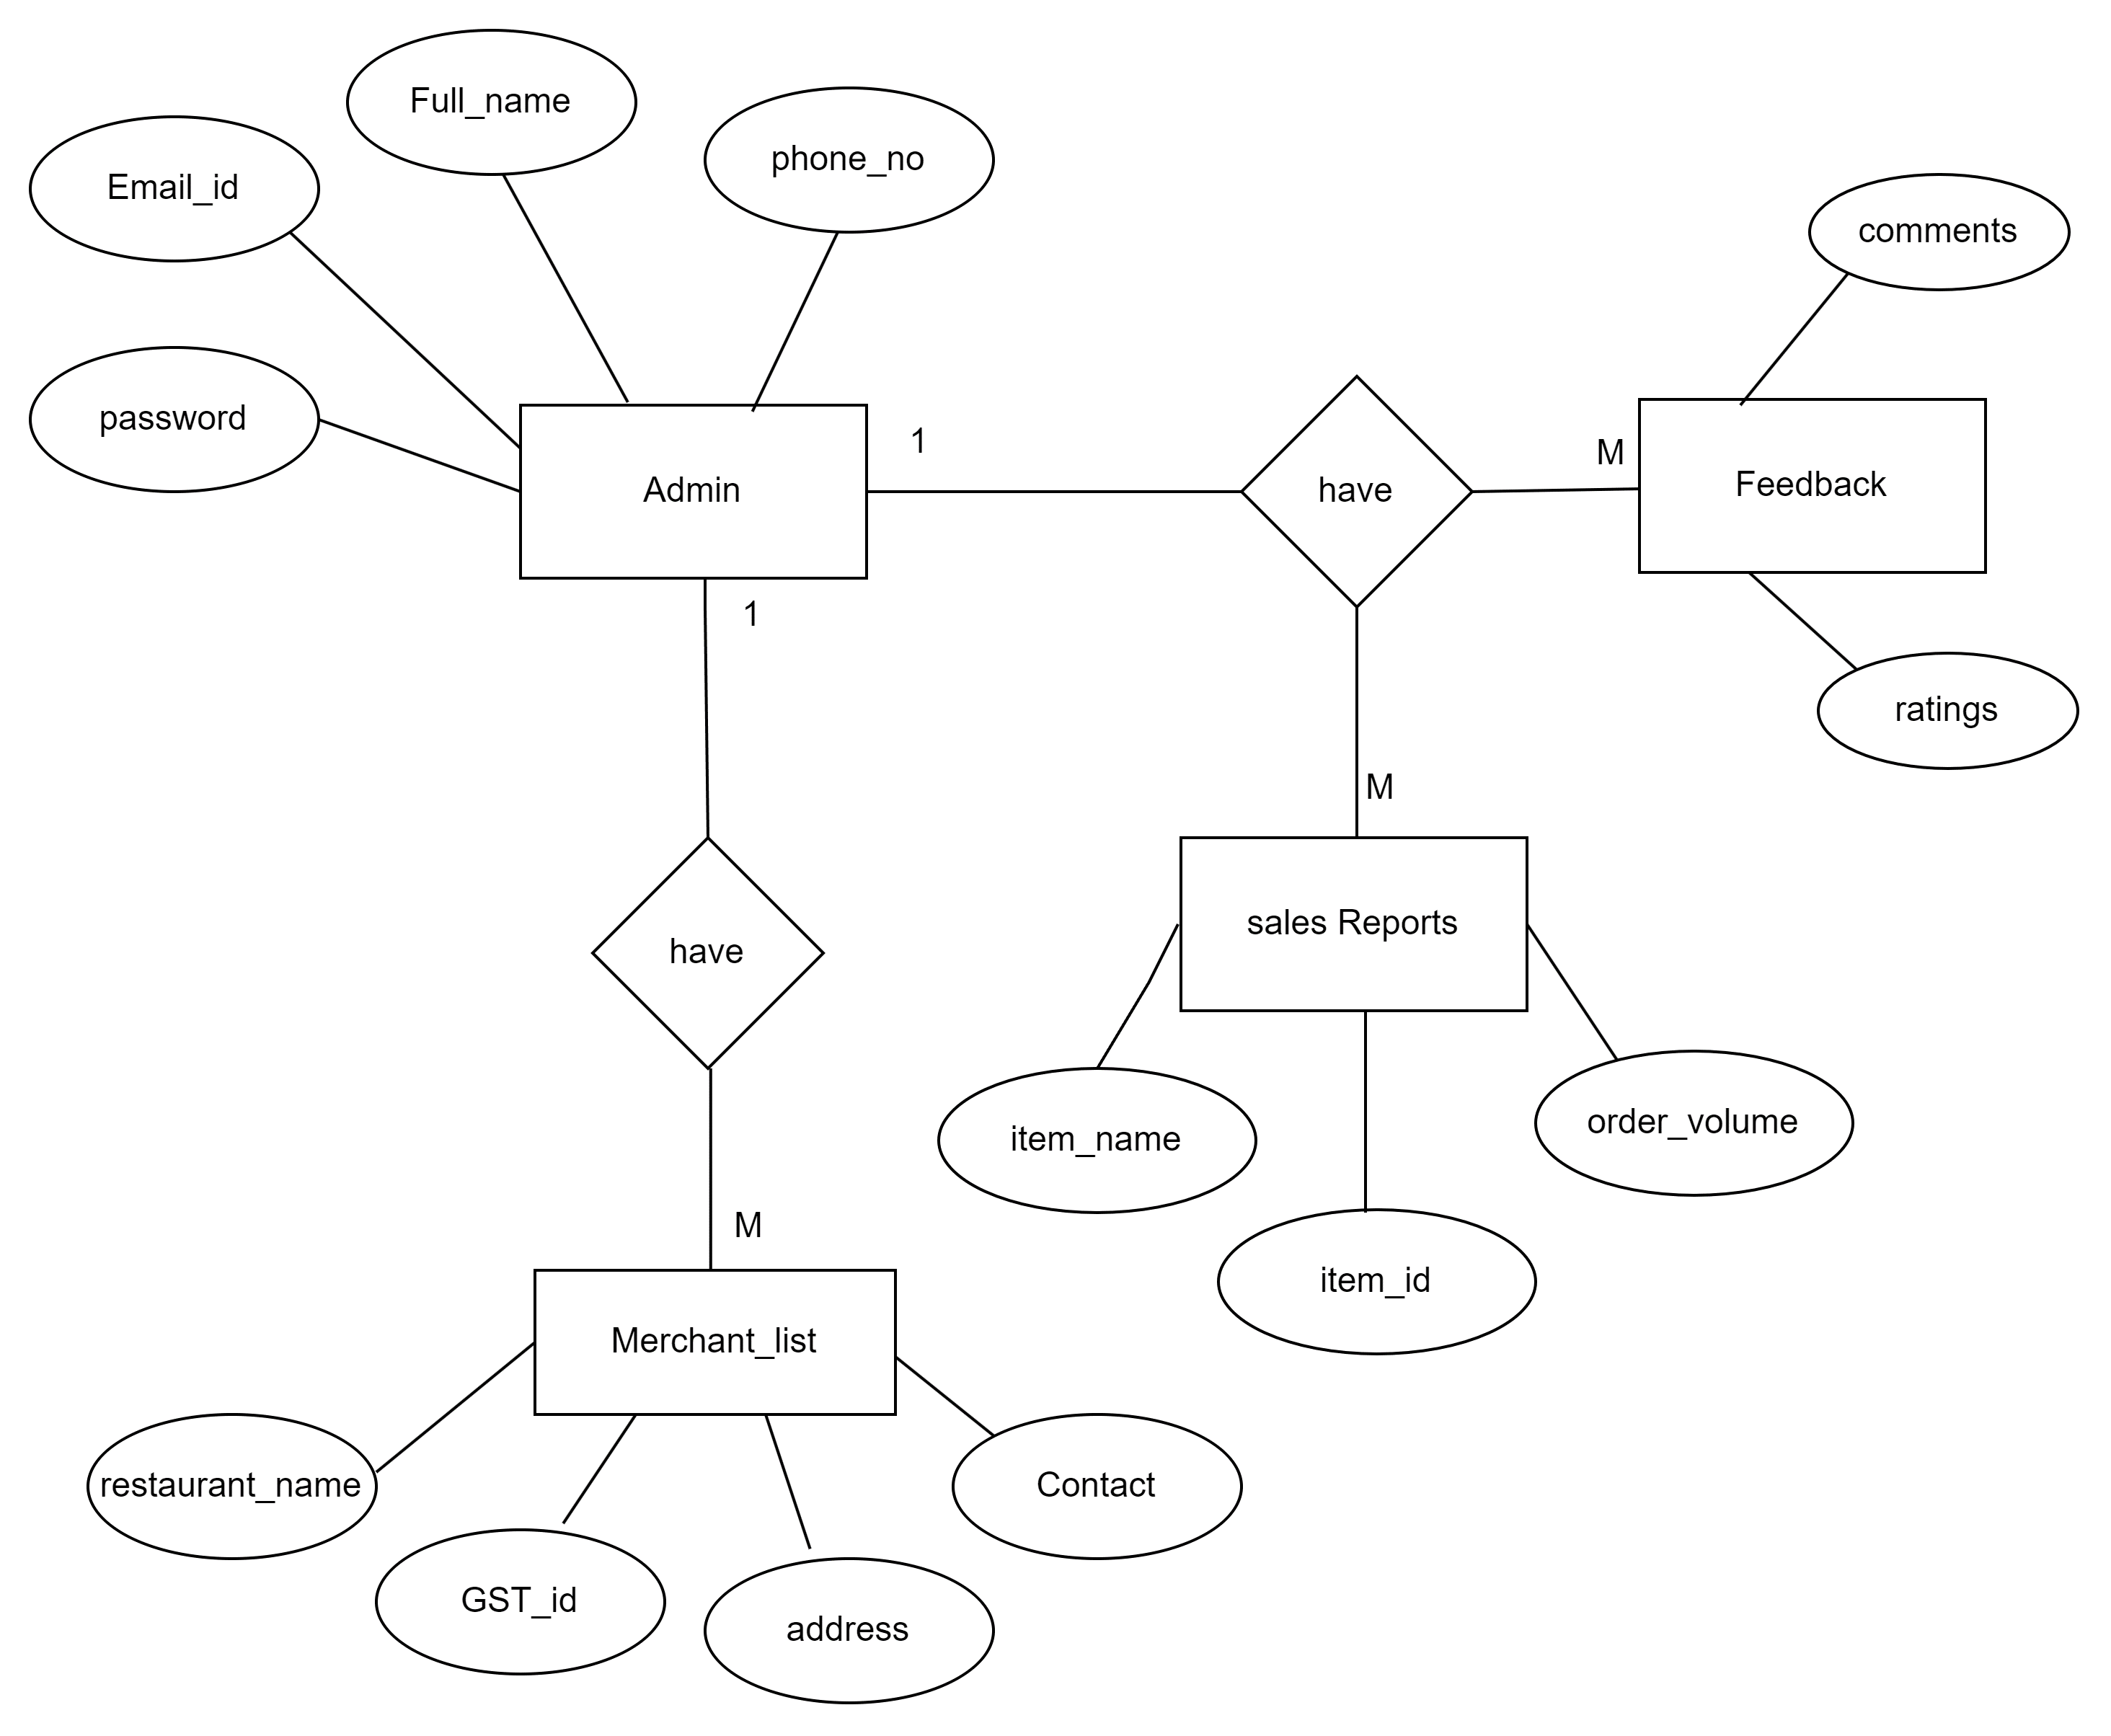

**Admin**